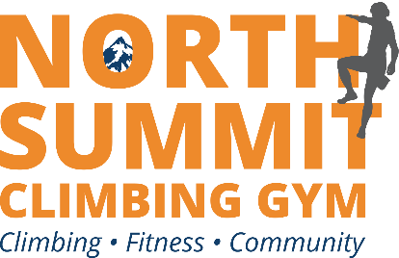

**North Summit is hosting a Rocktoberfest!**

We are celebrating Halloween on

**Sunday, October 31st 12-5pm**

Join us for fun, food and prizes!

**Come in costume and climb for HALF price.**

**The Lehigh Valley and Poconos’s**

**premier indoorrock climbing gym**

